**TEAM ID :PNT2022TMID31318**

**PROJECT NAME :SMART SOLUTIONS FOR RAILWAYS**

**CREATE NODE-RED SERVICE:**

**Step 1:**

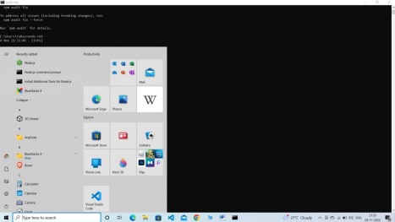

**Step 2:**

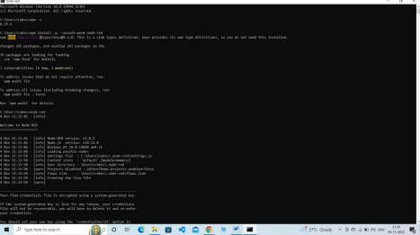

***Step 3:***

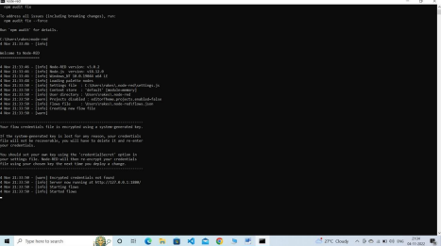

**Step 4:**

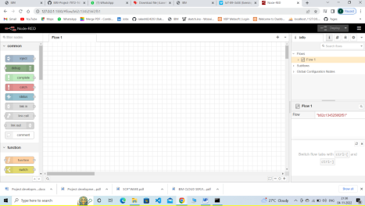

**LAST STEP :**

